**ARDUINO BASED SMART IRRIGATION SYSTEM USING IOT**

An automated irrigation system for efficient water management and intruder detection system has been proposed. Soil Parameters like soil moisture, pH, Humidity are measured and the Pressure sensor and the sensed values are displayed in LCD.

**ABSTRACT**

The project presents the use of correct soil moisture sensors which helps to ease out the pain to monitor and keep records about the changes in soil moisture. Using the Arduino Mega micro controller with Light-Depended Resistor sensor, moisture sensor and temperature sensor, temperature are measured and analyzed. The soil for a certain duration, provides information related to the moisture status of the soil. The Arduino Mega will collect and process the data received from the Sensors. When a threshold moisture level of the soil is reached, the water will supply accordingly. This is essential because water must be provided to the plant at a particular time for a good yield. This project is highly use for farmers, Nursery professionals by eradicating traditional or manual method of irrigation system.

# INTRODUCTION

Internet of Things can be defined as the collection of two terms: one is Internet, which is defined as networks of networks which can connect billions of users with some standard internet protocols. Internet connect several different sectors and department while using different technologies. Several devices like mobile, personal systems and business organizations are connected to Internet. The second term is Thing, this term is basically mean to these devices or objects which turn into intelligent objects. Moreover this it is also a part of all objects of this real world. If we want to define IOT then we can not define it precisely and concisely but Vermesan et al. defined the Internet of Things as simply an interaction between the physical and digital worlds. The digital world interacts with the physical world using a plethora of sensors and actuators .

**LITERATURE SURVEY**

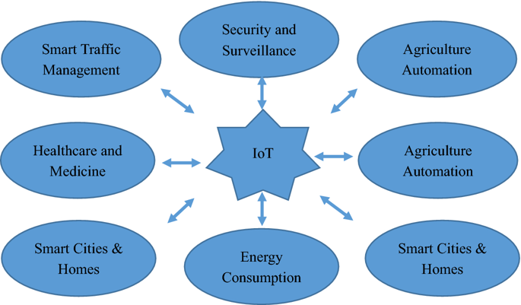

IoT has a multidisciplinary vision to provide its benefit to several domains such as environmental, industrial, public/private, medical, transportation etc. Different researchers have explained the IoT differently with respect to specific interests and aspects. The potential and power of IoT can be seen in several application domains. Illustrates few of the application domains of IoTs potentials.

**BLOCK DIAGRAM**

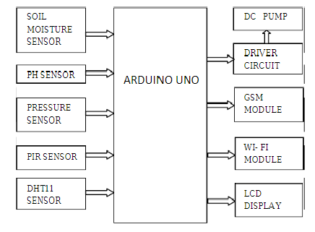

**HARDWARE DESIGNING**

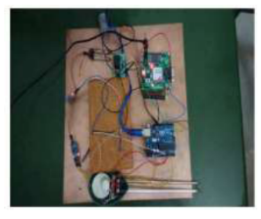

**ADVANTAGES**

1. **Data**: The more the information, the easier it is to make the right decision. Knowing what to get from the grocery while you are out, without having to check on your own, not only saves time but is convenient as well. 2. **Tracking**: The computers keep a track both on the quality and the viability of things at home. Knowing the expiration date of products before one consumes them improves safety and quality of life. Also, you will never run out of anything when you need it at the last moment. 3. **Time**: The amount of time saved in monitoring and the number of trips done otherwise would be tremendous. 4. **Money**: The financial aspect is the best advantage. This technology could replace humans who are in charge of monitoring and maintaining supplies.

**DISADVANTAGES**

1. **Compatibility**: As of now, there is no standard for tagging and monitoring with sensors. A uniform concept like the USB or Bluetooth is required which should not be that difficult to do. 2. **Complexity**: There are several opportunities for failure with complex systems. For example, both you and your spouse may receive messages that the milk is over and both of you may end up buying the same. That leaves you with double the quantity required. Or there is a software bug causing the printer to order ink multiple times when it requires a single cartridge. 3. **Privacy/Security**: Privacy is a big issue with IoT. All the data must be encrypted so that data about your financial status or how much milk you consume isn’t common knowledge at the work place or with your friends. 4. **Safety**: There is a chance that the software can be hacked and your personal information misused. The possibilities are endless. Your prescription being changed or your account details being hacked could put you at risk. Hence, all the safety risks become the consumer’s responsibility.

**APPLICATIONS**

* Smart home
* Wearables
* Smart City
* Smart grids
* Industrial internet
* Connected car
* Connected health (Digital health / Telehealth / Telemedicine)
* Smart retail
* Smart supply chain
* Smart forming

**CONCLUSION**

Recent advancements in IoT have drawn attention of researchers and developers worldwide. IoT developers and researchers are working together to extend the technology on large scale and to benefit the society to the highest possible level. However, improvements are possible only if we consider the various issues and shortcomings in the present technical approaches. In this survey article, we presented several issues and challenges that IoT developer must take into account to develop an improved model. Also, important application areas of IoT is also discussed where IoT developers and researchers are engaged. As IoT is not only providing services but also generates a huge amount of data. Hence, the importance of big data analytics is also discussed which can provide accurate decisions that could be utilized to develop an improved IoT system.

**FUTURE SCOPE**

This paper aims at developing the Smart Irrigation System Using IoT Technology with an objective of automating the total irrigation system which provide adequate water required by crop by monitoring the moisture of soil and climate condition in order to prevent the wastage of water resource.

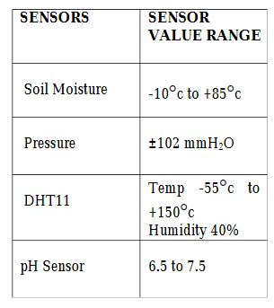

**APPENDIX**

